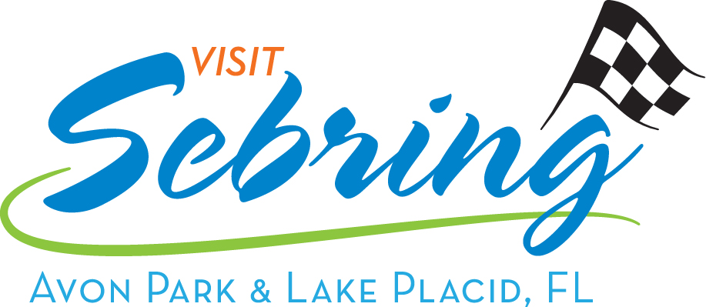

Highlands County Tourist Development Council
Highlands County Government Center, Boardroom

600 S. Commerce Ave, Sebring, Florida
March 28, 2019 at 8:15 a.m.

Draft Regular Meeting

1. The meeting was called to order at 8:15 a.m. by Acting Chair Commissioner Harris.

Roll Call

Council Members Present:
Commissioner Harris, Acting Chair Diane Rydecki
Bill Brantley Vicki Pontius
Leila Currence Mark Stewart
Cynthia Garren Jim Barnard

Council Members Absent:
Tenille Drury Smith
Also, Present:
Casey Hartt, Lead Tourist Development Council Consultant
Dana Knight, Tourist Development Administrative Assistant
Eileen May, lake Placid Chamber
Liz Barber, Sebring Chamber
Daniel Andrews, Heartland Triathlon

Acting Chair Commissioner Harris established that a quorum was present, and the meeting was properly noticed.

2. Acceptance of TDC Meeting Minutes of January 31, 2019

Acting Chair Commissioner Harris inquired if there were any comments or changes to the minutes of January 31, 2019. Ms. Pontius moved to accept the minutes of January 31, 2019 with corrections. Mr. Stewart seconded the motion. All the Council members voted aye. The motion carried.

3. Financial and Office Reports

Acting Chair Commissioner Harris presented the Monthly Expenditure and Revenue Reports for the month ending February 28, 2019.

Ms. Pontius made a motion and Mr. Stewart seconded the motion, to approve the financial reports as presented. All the Council members voted aye. The motion carried.

4. Marketing Update
A. March Marketing Report.

Ms. Hartt presented the March Marketing Report.

Acting Chair Commissioner Harris call Ms. Rybinski to address the Council.

Ms. Rybinski addressed the Council informing them that if they wish to continue to film the TDC meetings there will now be a cost due to additional Closed-Captioned equipment that has to be purchased to comply with ADA.

The Councils consensus was not to pay the additional cost.

5. Items for Voting
A. The Greater Lake Placid Chamber of Commerce request $1,000 to advertise the 29th
Annual Caladium Festival.

Ms. May presented the request.

Ms. Garren made a motion and Ms. Rydecki seconded the motion to recommend up to $1,000 to advertise outside of Highlands County the 29th Annual Caladium Festival. Funds to be disbursed from account 5304 Arts and Culture, with no room verifications required. All the Council members voted aye, except Mr. Brantley who abstained. The motion carried.

B. The Greater Lake Placid Chamber of Commerce request $1,000 to advertise the 23rd
Annual Caladium Festival Car Show.

Ms. May presented the request.

Ms. Garren made a motion and Ms. Currence seconded the motion to recommend up to $1,000 to advertise outside of Highlands County the 23rd Annual Caladium Festival Car Show. Funds to be disbursed from account 5305 Marketing and Promotion, with no room verifications required. All the Council members voted aye, except Mr. Brantley who abstained. The motion carried.

C. The Heartland Triathlon, Inc. request $5,000 to advertise the Heartland Triathlon.

Mr. Andrews presented the request.

Ms. Pontius made a motion and Mr. Stewart seconded the motion to recommend up to $5,000 to advertise outside of Highlands County the Heartland Triathlon. Funds to be disbursed from account 5305 Marketing and Promotion, with room verifications required. All the Council members voted aye, except Ms. Currence who abstained. The motion carried.

D. 2019 TDC Conference Schedule

Ms. Hartt presented the request.

Ms. Pontius made a motion and Ms. Garren seconded to approve the 2019 TDC Conference Schedule. All the Council members voted aye. The motion carried.

6. Old Business/Discussion

A. Strategic Planning Update

Ms. Hartt presented the Strategic Planning update.

Ms. Hartt informed the council that Mr. London will be returning to interview additional key people. His goal is to have the plan to us this summer.

B. Google Audit Update

Ms. Hartt presented the Google Audit update.

Ms. Hartt informed the council that Miles Media has been updating our Google locations and information. Ms. Hartt asked the Council to please make plans to attend the Google Industry Education Seminar after the Tourism Luncheon.

C. Postcard Mural Update

Ms. Hartt presented the Mural Update.

Ms. Hartt informed the Council that the County received one applicant. The Mural Review Committee will be meeting next week to review the applicant’s qualifications.

D. TDC Terms Expiring in May

Ms. Knight presented the Terms that are expiring.

Ms. Knight informed the Council that Mr. Brantley, Ms. Currence, Ms. Pontius and Ms. Garren’s TDC Member terms will expire on May 2, 2019.

E. Sebring Soda Festival Update

Ms. Barber presented an update on the Sebring Soda Festival.

Next weekend is the Sebring Soda Festival. Last year there were about 5,000 attendees. Ms. Barber stated she is confident that the numbers will increase this year due to the efforts of Ms. Hartt. Avery’s Beverages has created a Custom Sebring Soda, made just for the Sebring Soda Festival, and will be available for tasting and purchase exclusively at the Sebring Soda Festival. Much PR is also reaching out to anyone in the bottling or beverage industry to inform them of the event. They will also have 39 local nonprofit organizations at the event serving sodas. There will be 205 vendors from all over the country and Bubba Burgers will be there serving burgers. The after-party event that was designed to encourage visitors to stay overnight, will start at 8pm. They will have food pairings to go along with the beverages. We are excited about the momentum the event has.

7. Public Input

Input was not provided.

8. Board Member Roundtable

Ms. Garren reminded the Council that the Price is Right Show will be here Saturday.

9. Upcoming Meeting(s)
A. TDC Board: April 25, 2019 @ 8:15 a.m., Government Center, Boardroom.

10. Adjournment
Acting Chair Commissioner Harris adjourned the meeting at 9:11 a.m.

For all backup, contact Highlands County Public Information Office 863-402-6500.

