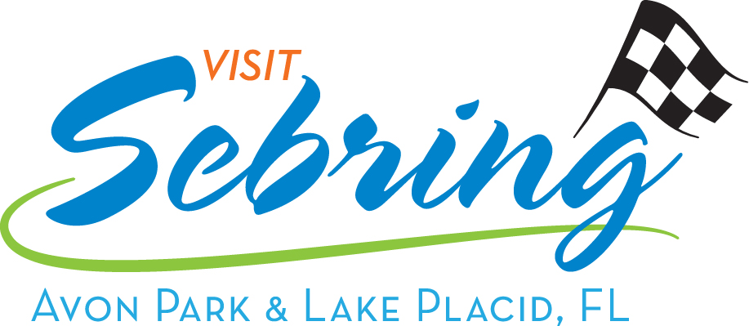

Highlands County Tourist Development Council
Highlands County Government Center, Boardroom

600 S. Commerce Ave, Sebring, Florida
January 31, 2019 at 8:15 a.m.

Draft Regular Meeting

1. The meeting was called to order at 8:15 a.m. by Chair Commissioner Brooks.

Roll Call

Council Members Present:
Commissioner Brooks, Chair Diane Rydecki
Bill Brantley Vicki Pontius
Leila Currence Mark Stewart
Cynthia Garren Jim Barnard

Council Members Absent:
Tenille Drury Smith
Also, Present:
Benjamin Dunn, Development Services Director
Casey Hartt, Lead Tourist Development Council Consultant
Dana Knight, Tourist Development Administrative Assistant
Milana Murillo, Avon Park Noon Rotary
Larry Lane, Sebring Rec Club
Gaylin Thomas, Heartland Cultural Alliance
Nadine Tedstone, Sebring Rec Club

Chair Commissioner Brooks established that a quorum was present, and the meeting was properly noticed.

2. Acceptance of TDC Meeting Minutes of December 6, 2018

Chair Commissioner Brooks inquired if there were any comments or changes to the minutes of December 6, 2018. Ms. Pontius moved to accept the minutes of December 6, 2018 with corrections. Ms. Rydecki seconded the motion. All the Council members voted aye. The motion carried.

3. Financial and Office Reports

Chair Commissioner Brooks presented the Monthly Expenditure and Revenue Reports for the months ending September 30, 2018 and October 31, 2018.

Ms. Garren made a motion and Ms. Rydecki seconded the motion, to approve the financial reports as presented. All the Council members voted aye. The motion carried.

4. Marketing Update
A. December and January Marketing Report.

Ms. Hartt presented the December and January Marketing Report.

5. Items for Voting
A. Rotary Club of Avon Park request $1,000 to advertise outside of Highlands County the
9th Annual Avon Park Rotary Bluegrass & Blueberry Festival.

Mr. Barnard made a motion and Ms. Garren seconded the motion to recommend up to $1,000 to advertise outside of Highlands County the 9th Annual Avon Park Rotary Bluegrass & Blueberry Festival. Funds to be disbursed from account 5304 Arts and Culture, with no room verifications required. All the Council members voted aye. The motion carried.

6. Old Business/Discussion
A. Update on Regatta-Run

Ms. Celentano sent a letter to Commissioner Brooks that was distributed to the Council.

After a discussion the Council ‘s consensus was to accept Ms. Celentano’s retraction and suggested that she return to request the $5,000 or $1,000 grant.

B. Strategic Planning Update

Ms. Hartt presented the update.

Public input was received from Ms. Thomas.

C. Google Audit Update

Ms. Hartt presented the update

D. Postcard Mural Update

Mr. Dunn informed the Council that the County will be advertising for artist this week end.

7. Public Input

Mr. Lane gave a brief overview of the events offered at the Sebring Rec Club.

8. Board Member Roundtable

Ms. Pontius asked if any of the Council Members would like to change the TDC meeting start time to 9:00AM. Consensus was to keep the start time at 8:15AM.

Ms. Hartt informed the Council that the 2019 Passports are now available.

Ms. Thomas stated that the Passports are having a positive impact on their business.

Ms. Garren suggested cutting the number of attractions needed to qualify from 10 to 5.

Ms. Rydecki reminded the Council that the reason it is set at 10 is to encourage people to return and generate more overnight stays.

9. Upcoming Meeting(s)
A. TDC Board: February 28, 2018 @ 8:15 a.m., Government Center, Boardroom.

10. Adjournment
Chair Commissioner Brooks adjourned the meeting at 9:28 a.m.

For all backup, contact Highlands County Public Information Office 863-402-6500.

